**October 12, 2014**

**Volume 3, Issue 7**

Sunday School Times

***Stuff For Today***

• Wait, Wait, Let Me Guess, and of course everybody’s hero—Bob the Square!

• More about pineapple thievery in Indonesia.

• If you put everything you call your own on a table, could you walk away from it all and not look back?

Published almost weekly, but more like…..whenever, so get used to it, OK?

# Can You Afford to be a Christian?

**By Mr. Lyle (mrlyle1@gmail.com)**

[***Luke14:33***](http://www.biblegateway.com/passage/?search=Luke+14:33&version=KJV) *So likewise, whosoever he be of you that****forsaketh****not****all****that he hath, he cannot be my disciple*

We are told in the Word to count the cost of being a disciple. That statement has little, if anything, to do with our money It is a warning to us that following Christ is not going to be simple. Jesus taught that we should expect opposition from the culture we live in.

Salvation is free to be sure, and for too many, the journey towards spiritual maturity ends there. Christians are called to be sanctified. In short, the goal of a Godly Christian is to be wholly committed to deepening his or her walk with God. Every day we must die to our selfish desires, and put Jesus first.

Our fast paced, materialistic culture drains us many times of our total commitment to Christ, leaving us bound up in worldly things, and missing the blessings we could have had.

So, is it wrong to be wealthy, or have nice things? If what we have in any way takes our focus off of God—yes it is a problem. And yet, God wishes to bless his children in every way.

Money, or talents or abilities--everything we have--belongs to God. As Adam tended the Garden of Eden, we also are to care for what He has entrusted to us. May we be spiritually mature enough to properly handle His gifts.

We will continue today with the story of missionary Otto Koenig. In part one, last week, we were introduced to a pineapple garden in Irian Jaya Indonesia, and some natives who continually stole the pineapples growing there.

Mr. Koenig struggled with applying Luke 14:33 to real life situations. His story, although somewhat comical at times, is an excellent example to us of how the truth of the Word of God needs to be considered in all parts of our everyday lives.



**Here and There in the News This Week**

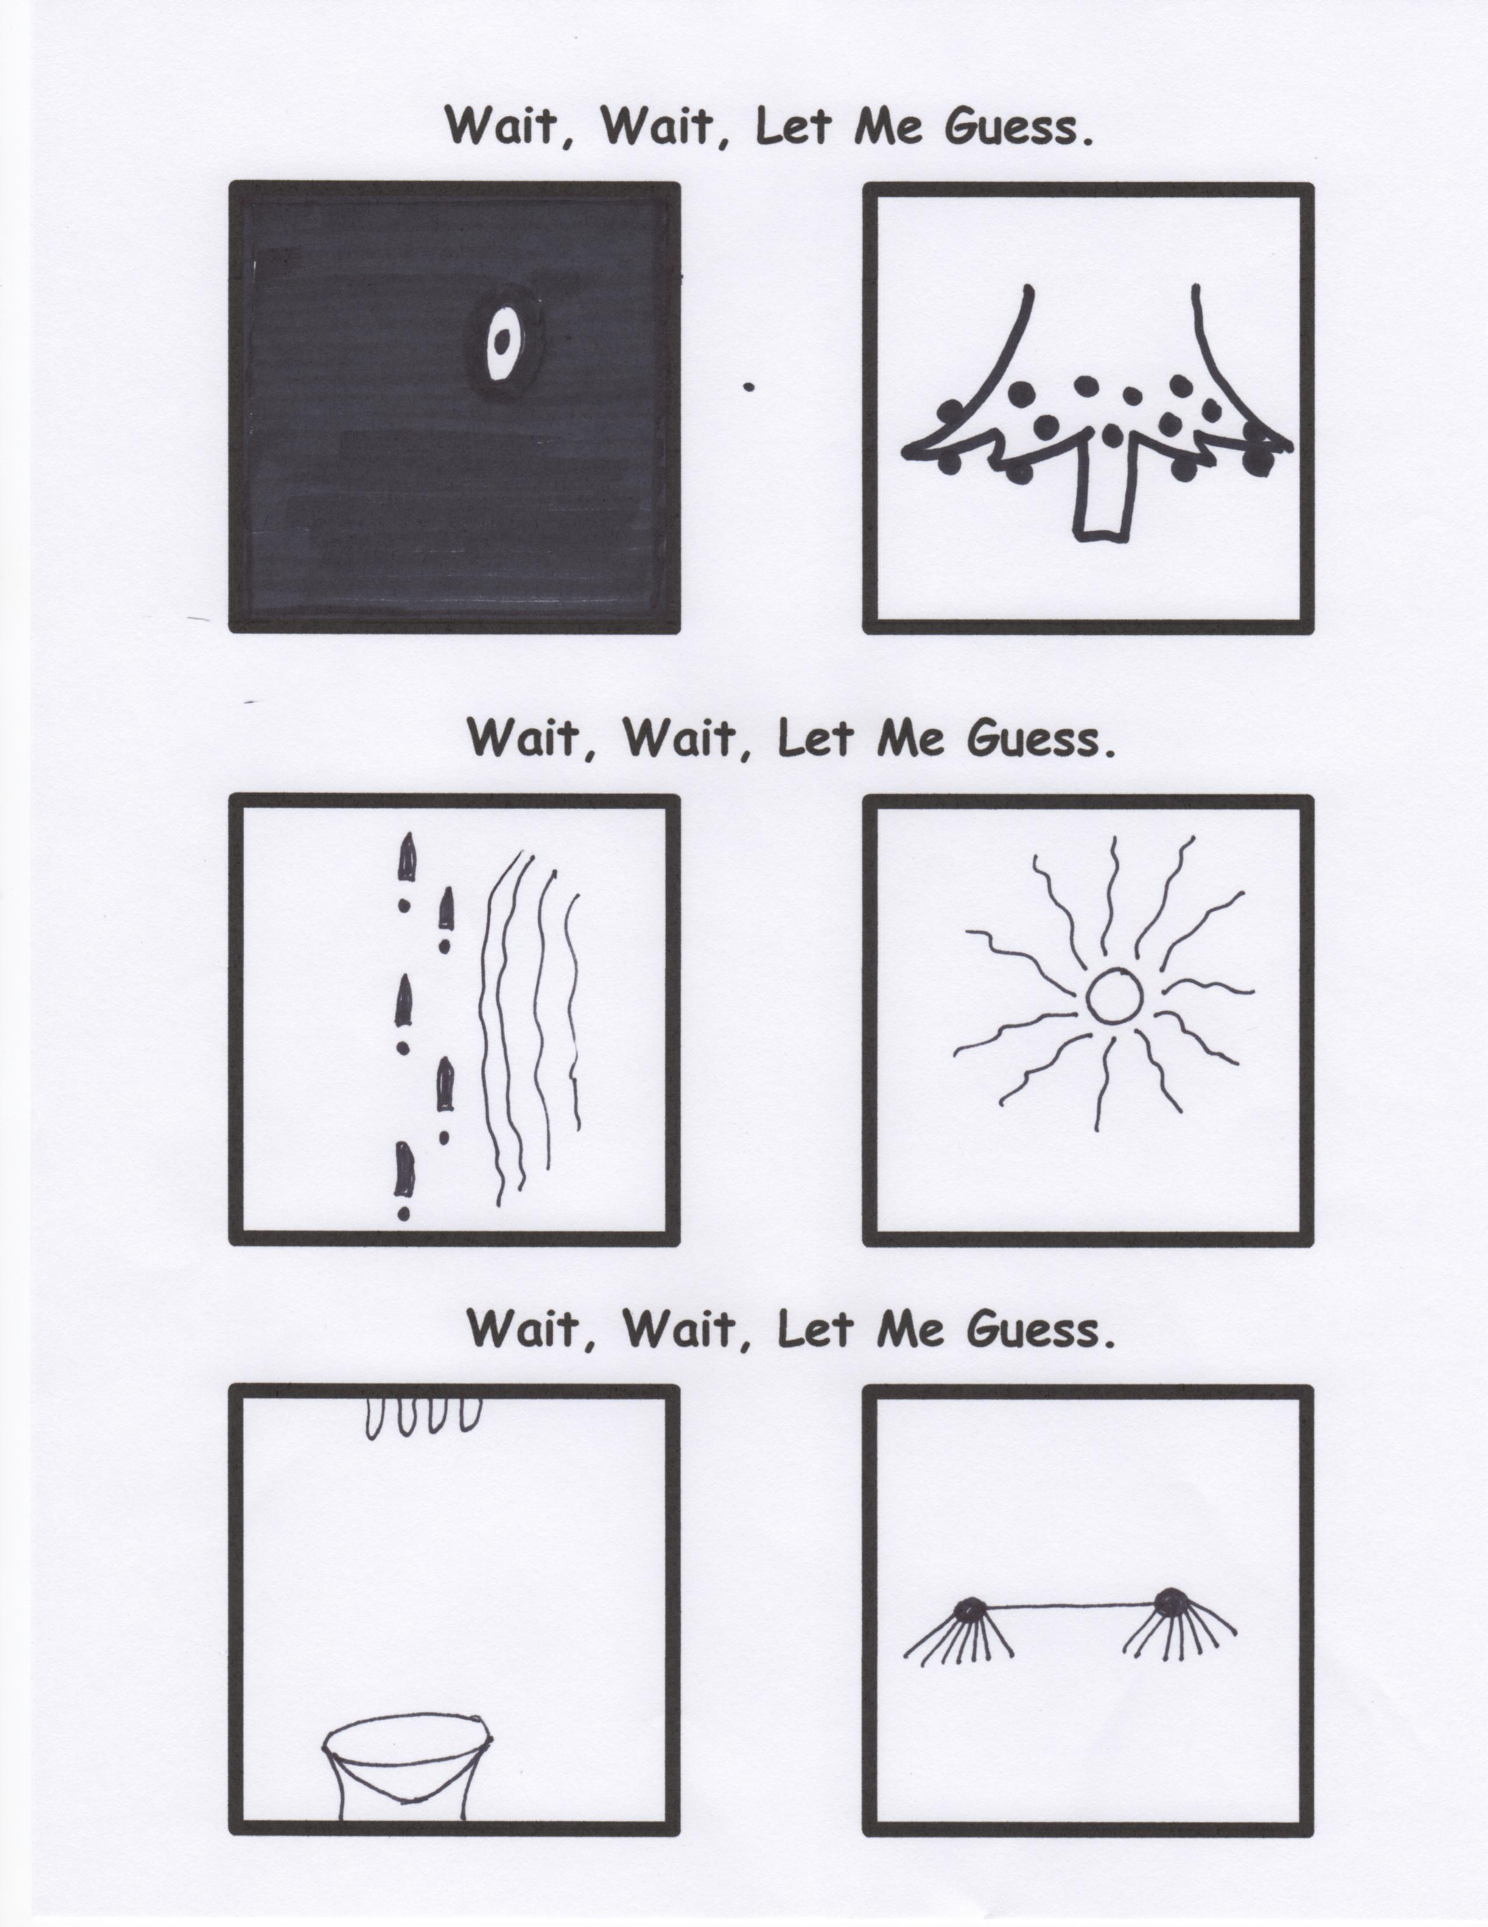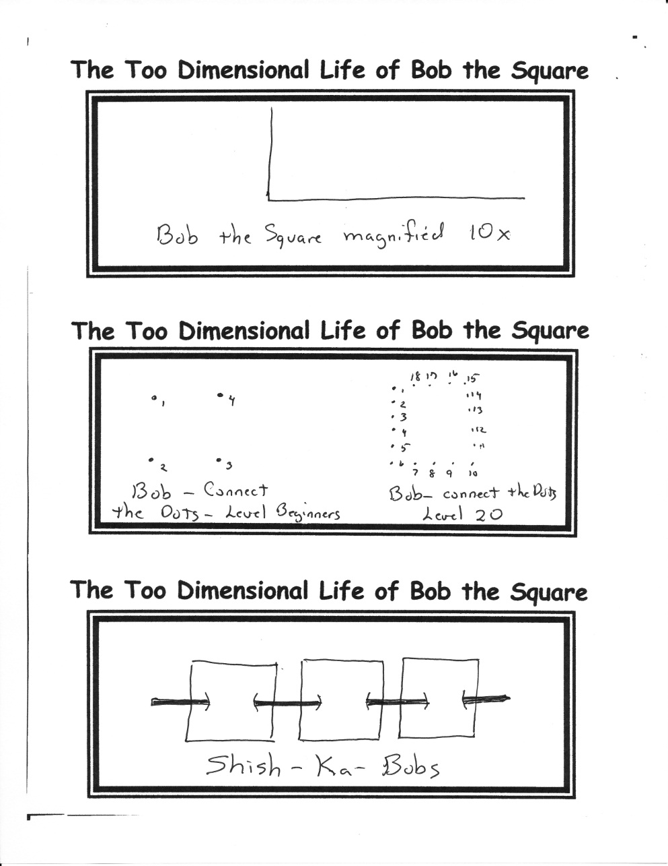

Mark October 19th on your calendar! Mark 12:00 on your watch! Mark Dow Chemical on your maps! Immediately following the morning service that day, we are headed for lunch. Be there!

**Cookout Coming!**

1. Astronomers announced recently the possible discovery of an entirely new type of planet. Nearly 40 light years away, the planet measures approximately twice the size of Earth, and is made primarily of carbon. It may very well be made largely of diamonds. Only God could show us how insignificant our most prized possessions actually are!

2. “Hello, my name is Inigo Montoya. You killed my father. Prepare to die.” The most recognized quote from ***The Princess Bride*** is now 26 years old. A so-so movie in the theaters of that day, it has become a family classic. If you have never watched it, and have a couple of hours to spend, you will enjoy this one.

By Mr. Lyle (mrlyle1@gmail.com)