**August 10, 2014**

**Volume 2, Issue 42**

Sunday School Times

***Stuff For Today***

• Remembering

• Graduation

* Goodbye!

Published almost weekly, but more like…..whenever, so get used to it, OK?

**By Mr. Lyle (mrlyle1@gmail.com**

**How many of these lessons do you remember?**

1. Finding a watch under one of three cups.

2. George Wilson’s pardon.

3. Prince Charmin.

4. The rat trap

5. Hu Waru

6. The celebration of COTSA

7. Jesus’ first sermon

8. Funeral for a friend

9. The story of Ruth

10. A Kroger Christmas

11. Famous artist Ly Lé

12. The Gospel in the gates of Jerusalem

13. Four faced creatures

14. The impossible football game

15. RATZ: Reveal Another Terrific Zero

16. The 100 mm canon

17. Kung Fu Moses

18. Magnets

19. The cabbage coupon

20. Pencil parable

21. Four letter Latin swear word

22. Picking the Lamb

23. Hatfileds and McCoys

24. William Tell

25. First and last word in the Old Testament

26. The soap opera

27. To Tell the Truth

28. Gravity Corner

29. Keep Living an Excellent Witness

30. Really lame magic tricks—and one disappearing Coke bottle

31. And who can forget those amazing “Wait, Wait Let Me Guess”

**Today’s Graduation Ceremony**

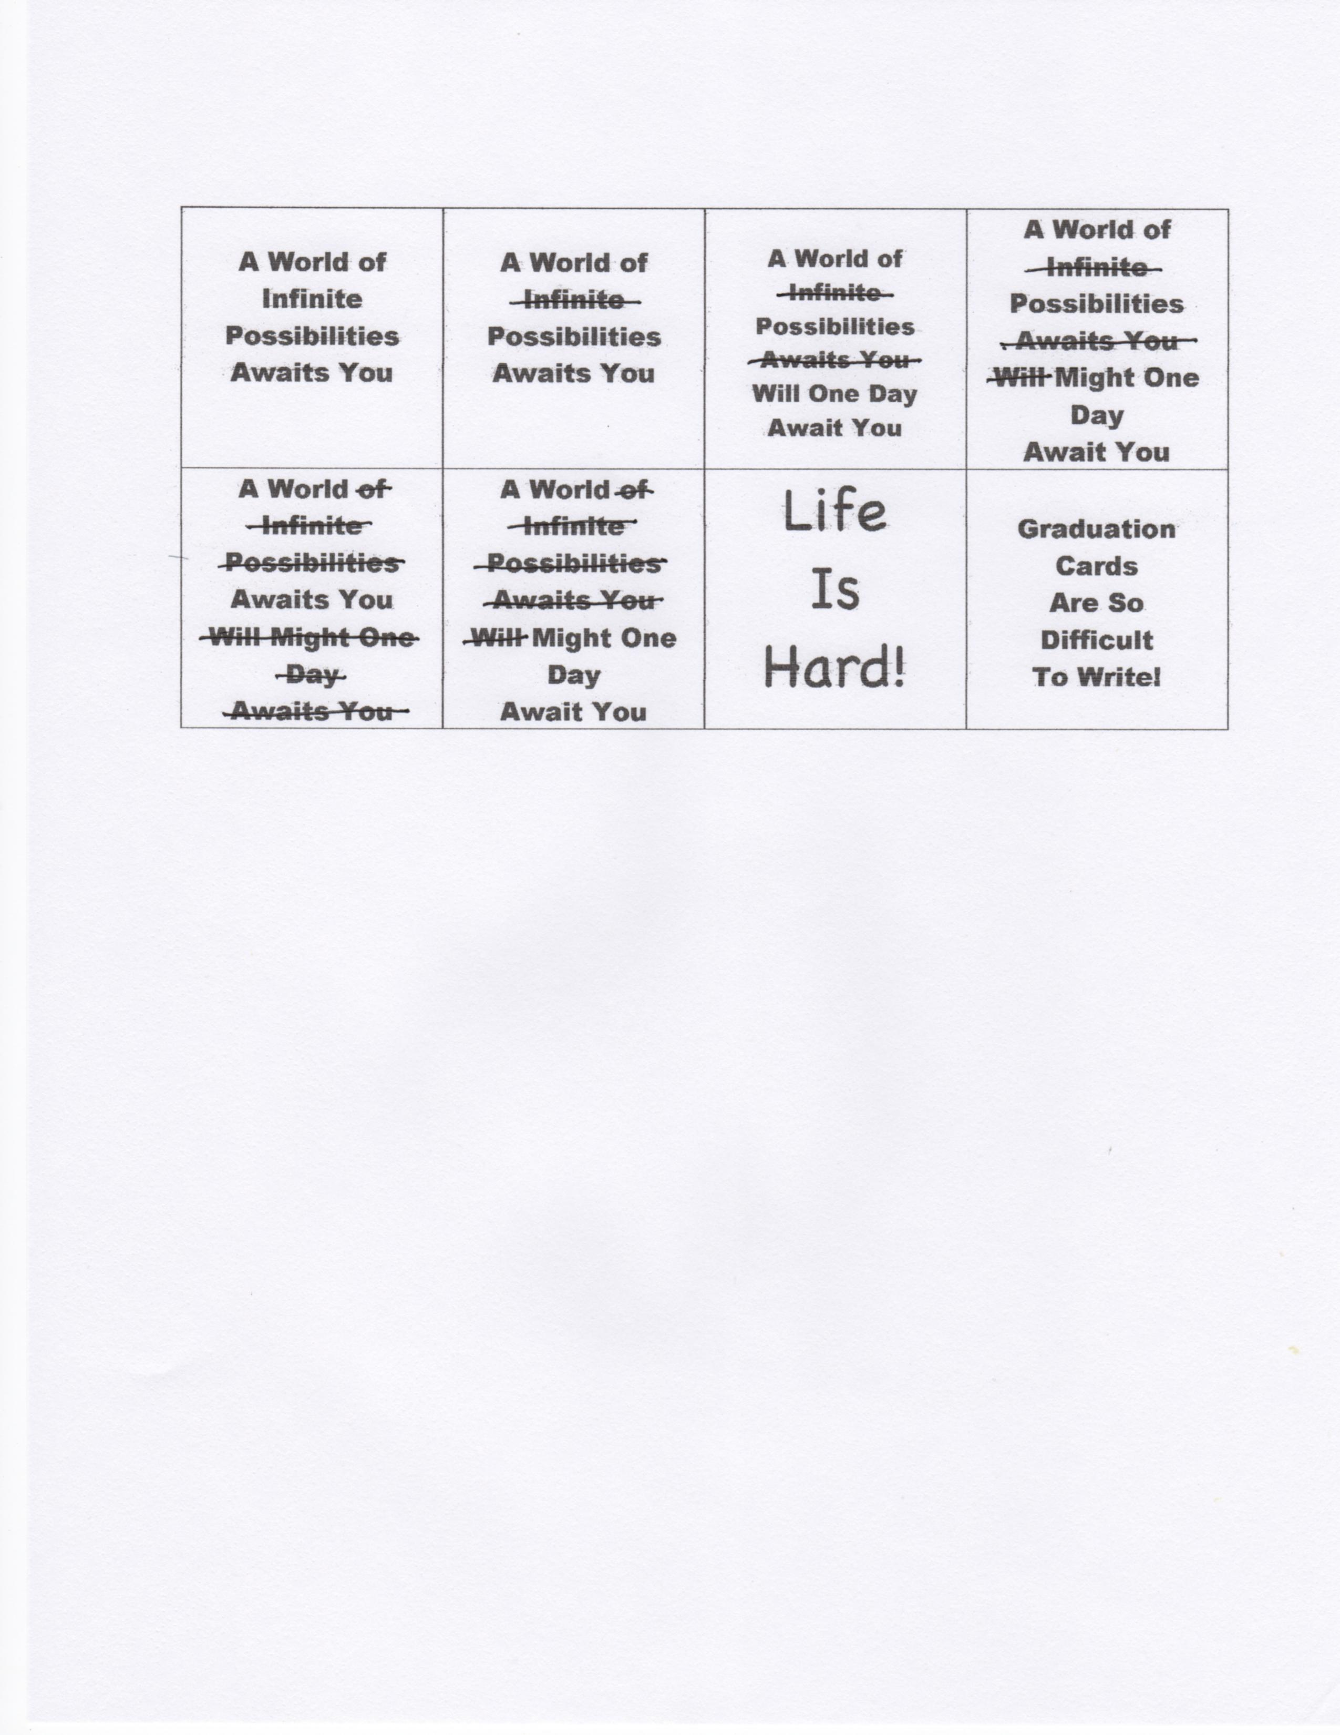

By Mr. Lyle (mrlyle1@gmail.com)

Welcome and Prayer

Pomp and Circumstances beyond our control

The Reading of the Sunday School Times

Announcments

Address by Class Valasalutadictatorian

Magnanimous

Canunimous

Laudinum

Presentation of Diplomas and Various Other Unsundry Items

Closing Prayer

You’re Outa Here!

**Good Bye**

See you later, alligator

After awhile, crocodile

In an hour, sunflower

Toodle-oo, kangaroo

Gotta go, buffalo

Adios, hippos

Chow chow, brown cow

See ya soon, baboon

Adieu, cockatoo

Better swish, jellyfish

Chop chop, lollipop

Bye Bye, butterfly

See ya mañana, iguana

Give a hug, ladybug

Can’t stay, blue jay

Farewell, gazelle

Take care, brown bear

Stay loose, bull moose

Good wishes, little fishes

Gonna hit the road, spotted toad

I’m outa here, white tailed deer

**I would just like to take a few moments to congratulate** **myself on sitting through your graduation ceremony.**