**January 12, 2014**

**Volume 2, Issue 17**

Sunday School Times

***Stuff For Today***

• Wait, Wait, Let Me Guess

• Recall notice

* Ly Lé

Published almost weekly, but more like…..whenever, so get used to it, OK?

# The Portraits of the Famous

# 20th Century French Artist Ly Lé

***Isaiah 1: 18b***

***“Though your sins are like scarlet,     they shall be as white as snow; though they are red*** as ***crimson,     they shall be like wool.***

Initially, most may find it odd to ask the simple question: “If sin was described by its color, what hue comes to mind?” Often the answer given refers to a shade of black, as black is the opposite of pure white.

God places an interesting description in the Bible. Isaiah quotes God talking to Israel of their sin, and He refers to it as being red, scarlet, crimson, or burgundy.

At first glance that may seem odd, but a short lesson in the physics of light gives at least one interesting bit of insight into the unique color reference.

Known well by a small but loyal group of followers, the French artist Ly Lé has been rendering portraits of one particular individual for over fifty years. An un-named collector of his works has consented to display his very first portrait of this nameless individual. We will have the chance to examine first hand the subtle nuances of color and textures used by Ly Lé.

During the art presentation we will be fortunate enough to see his very latest portrait—drawn, as it were, with a hole in his side. Careful observation will reveal that Ly Lé chose to color the exposed heart red.

Using this amazing portrait, we will show how light and color react when the entire portrait is viewed through a red lens. (A hint: the red is no longer visible!)

When we turn our lives over to Jesus and become Christians, God says that the blood of Jesus covers us. We are forgiven because of the Atonement of Christ. The very word “atone” means to cover.

God forgives us of our sins, but none of us continues in perfection after that moment. Fortunately God’s solution is adequate to cover our sins and allow us to stand in His presence. The precious blood that Jesus shed for us covers our sin.

What color is blood? Red of course. What color is sin? red also. And just as the demonstration shows the seeming “disappearance” of the red heart in Ly Lé’s portrait, so the blood of Jesus creates the “disappearance” of our sin as well, allowing a Holy, Perfect, God to draw near to us and call us His own.

And by the way, don’t bother to GOOGLE the artist Ly Lé. You won’t find him! He is a complete fabrication of my imagination. (At least I think so.)

By Mr. Lyle

**Manufacturer’s Recall Notice**

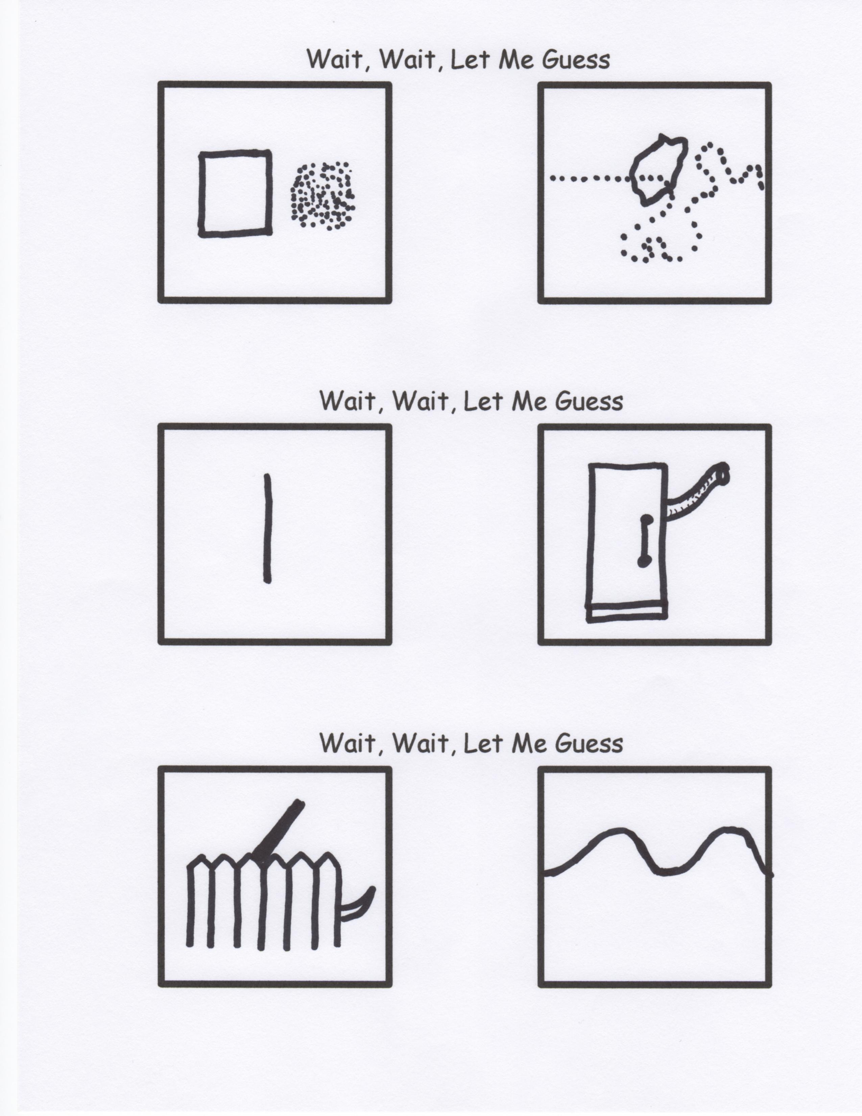

The Maker of all human beings is recalling all units manufactured, regardless of make or year, due to the serious defect in the primary and central component of the heart. This is due to a malfunction in the original prototype units code named A.D.A.M. and E.V.E., resulting in the reproduction of the same defect in all subsequent units. This defect has been technically termed, “Sub-sequential Internal Non-morality”’ or more commonly known as SIN as it is primarily expressed.

Some symptoms of this problem include:

(a). Loss of direction

(b). Confusion of the mental component

(c). Amnesia of origin

(d). Foul vocal emissions

(e). Erratic self-destructive behaviors.

The Manufacturer, Who is neither liable or at fault for this defect, is providing authorized repair service free of charge to correct the SIN defect. The Repair Technician, Jesus, has most generously offered to bear the entire burden of the staggering cost of these repairs.

There is no additional fee required. The number to call in all areas is P-R-A-Y-E-R. Once connected please up load your burden of SIN through the REPENTANCE procedure. Next download ATONEMENT from the Repair Technician, Jesus, into the heart component.

Please see and use the readily available operating manual HOLY BIBLE for further details on the use of these fixes. With the upgrade, the Manufacturer has made available to all repaired units a facility enabling direct monitoring and assistance, from the resident Maintenance Technician, the Holy Spirit.

**WARNING:** Continuing to operate the human being unit without corrections voids the Manufacturer’s warranty, exposing the unit to dangers and problems too numerous to list, and will result in the human unit being permanently impounded.

For free emergency service call on J-E-S-U-S. This is of course a toll free call.

**DANGER:** The human being units not responding to this recall action will have to be scrapped and disposed of by burning. The SIN defect will not be permitted to enter the Heaven Facility, so as to prevent contamination of that facility.

Thank you for your attention. Please assist where possible by notifying others of the important recall notice.