**December 15, 2013**

**Volume 2, Issue 14**

Sunday School Times

***Stuff For Today***

• Wait, Wait, Let Me Guess

• Christmas trivia

* A Kroger Christmas

Published almost weekly, but more like…..whenever, so get used to it, OK?

# 13th Annual Kroger Christmas

**By Mr. Lyle (mrlyle1@gmail.com)**

***Luke 1: 26-38***

***26****In the sixth month of Elizabeth’s pregnancy, God sent the angel Gabriel to Nazareth, a town in Galilee,* ***27****to a virgin pledged to be married to a man named Joseph, a descendant of David. The virgin’s name was Mary.* ***28****The angel went to her and said, “Greetings, you who are highly favored! The Lord is with you.”* ***29****Mary was greatly troubled at his words and wondered what kind of greeting this might be.* ***30****But the angel said to her, “Do not be afraid, Mary; you have found favor with God.* ***31****You will conceive and give birth to a son, and you are to call him Jesus.* ***32****He will be great and will be called the Son of the Most High. The Lord God will give him the throne of his father David,* ***33****and he will reign over Jacob’s descendants forever; his kingdom will never end.”* ***34****“How will this be,” Mary asked the angel, “since I am a virgin?”* ***35****The angel answered, “The Holy Spirit will come on you, and the power of the Most High will overshadow you. So the holy one to be born will be called****[b]*** *the Son of God.* ***36****Even Elizabeth your relative is going to have a child in her old age, and she who was said to be unable to conceive is in her sixth month.* ***37****For no word from God will ever fail.”* ***38****“I am the Lord’s servant,” Mary answered. “May your word to me be fulfilled.” Then the angel left her.*

***Luke 2***

***2****In those days Caesar Augustus issued a decree that a census should be taken of the entire Roman world.* ***2****(This was the first census that took place while Quirinius was governor of Syria.)* ***3****And everyone went to their own town to register.* ***4****So Joseph also went up from the town of Nazareth in Galilee to Judea, to Bethlehem the town of David, because he belonged to the house and line of David.* ***5****He went there to register with Mary, who was pledged to be married to him and was expecting a child.* ***6****While they were there, the time came for the baby to be born,* ***7****and she gave birth to her firstborn, a son. She wrapped him in cloths and placed him in a manger, because there was no guest room available for them.* ***8****And there were shepherds living out in the fields nearby, keeping watch over their flocks at night.* ***9****An angel of the Lord appeared to them, and the glory of the Lord shone around them, and they were terrified.* ***10****But the angel said to them, “Do not be afraid. I bring you good news that will cause great joy for all the people.* ***11****Today in the town of David a Savior has been born to you; he is the Messiah, the Lord.* ***12****This will be a sign to you: You will find a baby wrapped in cloths and lying in a manger.”* ***13****Suddenly a great company of the heavenly host appeared with the angel, praising God and saying,* ***14*** *“Glory to God in the highest heaven,     and on earth peace to those on whom his favor rests.”* ***15****When the angels had left them and gone into heaven, the shepherds said to one another, “Let’s go to Bethlehem and see this thing that has happened, which the Lord has told us about.”* ***16****So they hurried off and found Mary and Joseph, and the baby, who was lying in the manger.* ***17****When they had seen him, they spread the word concerning what had been told them about this child,* ***18****and all who heard it were amazed at what the shepherds said to them.* ***19****But Mary treasured up all these things and pondered them in her heart.* ***20****The shepherds returned, glorifying and praising God for all the things they had heard and seen, which were just as they had been told.*

**Really…How Well Do You Think You Know Christmas?**

**Yup**

**Nope**

**Dunno**

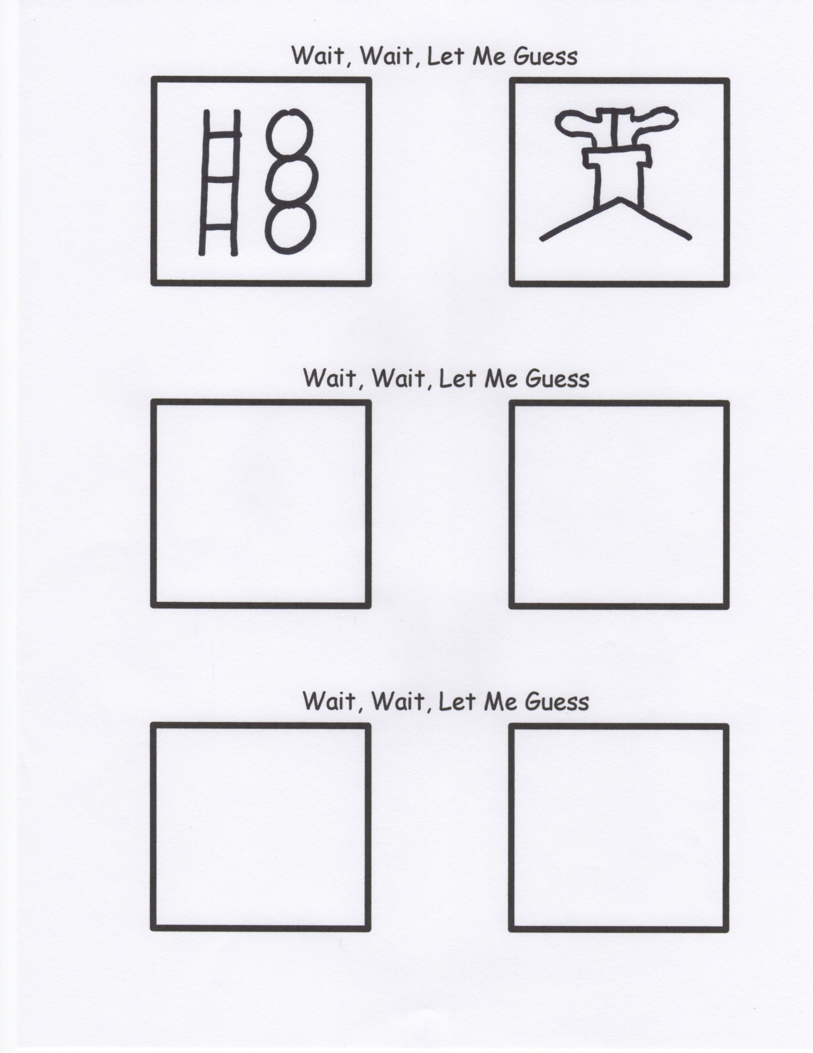

***How Well Do You Know Christmas?***

1._____There are 32 “la”s in the first verse of “Deck the Halls”.

2._____”Jingle Bells” never mentions Christmas.

3._____”Silent Night” was originally written for guitar.

4._____”Joy to the World” was not written as a Christmas song.

5._____Snowflakes have 6 sides.

6._____Animal cracker boxes have strings on them so they can be used as Christmas tree decorations.

7._____Pointsettias, mistletoe, and holly are all poisonous.

8._____Snowmen fall from the sky unassembled.

9._____Santa did not live at the North Pole until 1882.

10.____Santa’s North Pole has an official Canadian Zip Code.

11.____Mistletoe means “bird poo on a twig”.

12.____Both male and female reindeer have antlers.

13.____Rudolph’s real name is Rollo. He was also known as Reginald.

14.____All Santa’s reindeer are males.

1._____Gabriel told Mary she would have a son.

2._____Jesus was named before He was born.

3._____Mary and Joseph were married when Jesus was announced.

4._____Jesus and John the Baptist are related.

5._____Ceasar commanded all to be registered for taxes.

6._____Joseph was from Bethlehem.

7._____Mary rode a donkey to Bethlehem.

8._____When they got to Bethlehem, the Inn keeper said there was no room for them.

9._____They were allowed to use a stable instead.

10.____Jesus was born in a stable.

11.____Jesus was the only baby ever born who was older than his mother.

12.____There were animals there.

13.____Jesus’ first bed was a feed trough.

14.____Jesus was born on December 25th.

15.____God chose shepherds because they were well respected men in the community.

16.____An angel appeared at night with a message for them.

17.____The angel appeared in the sky.

18.____The angel was very frightening because he was so bright.

19.____An angel choir sang to the shepherds.

20.____The angels then suddenly disappeared into the night sky.

21.____The shepherds then hurried to see the baby Jesus.

22.____They found everything just as they had been told.

23.____The shepherds stayed a long time at the manger.

24.____An arch angel was above the manger.

25.____Three wise men came to the manger with gifts.

26.____They showed up right after the shepherds left.

27.____They had followed a star to the manger.

28.____The gifts they brought were significant.

29.____Mary understood everything about what had happened that night.

30.____And everybody lived happily ever after.