**December 1, 2013**

**Volume 2, Issue 13**

Sunday School Times

***Stuff For Today***

• Wait, Wait, Let Me Guess

• Pumpkin pie

* Man’s survival
* Questions and Answers

Published almost weekly, but more like…..whenever, so get used to it, OK?

# A Place Not Found On Google Maps

**By Mr. Lyle (mrlyle1@gmail.com)**

***Isaiah 7:3***

***Then said the Lord unto Isaiah, Go forth now to meet Ahaz, thou, and Shearjashub thy son, at the end of the conduit of the upper pool in the highway of the fuller's field.***

Christmas season and the accompanying celebrations help us to remember the passage in Isaiah 7:14. As remarkable as is the content of these verses, so is the physical location they were first quoted. God wanted a face to face meeting between the king of Judah, Ahaz, and His prophet, Isaiah, at a very specific location. Few places in Scripture are as exacting in description as this one. That fact spurs some interest and inquiry. Isaiah 7:3 presents these geographical notes. The meeting was to take place at the *end of the conduit.* God had promised David that his family line would always sit upon the throne of Israel. That family tree was the conduit through which Jesus claims rightful ownership of the throne. He is at the end of that line, the final King who will rule and reign forever. The conduit empties into *the upper pool.* In Israel, water is precious and a blessing. A body of water, a pool, is literally the word for blessing in the Hebrew. And the word *upper* elsewhere in Scripture is translated Most High when referring to God Himself. Jesus, the Most High God is indeed a blessing to all. The remaining phrase, *in the highway of the fuller’s field*, is an allusion to an elevated roadbed, one that keeps the traveler out of the mud and muck through which the road extends. As we look to Christ in our everyday walk, we need holiness. It is essential to keep our lives out of the dirt and filth that the rest of the world so easily entangles itself in. *The fuller’s field* is a laundry of that day. The only way that we can be truly sanctified in our daily walk, is to be cleansed of our sin and that can come by no one but the Savior Himself. It is no accident that God chose to articulate one of the promises of His coming Son at this very allegorical location.

**Pumpkin Pie: Before and After**

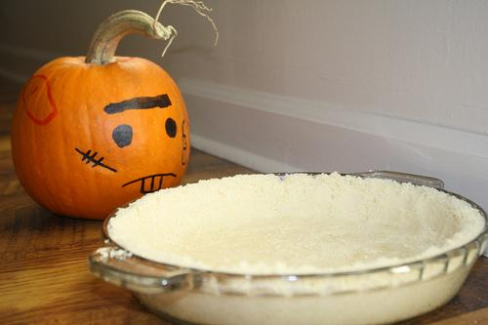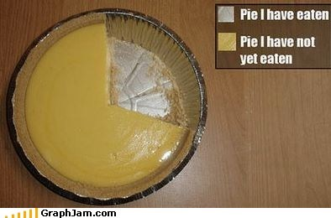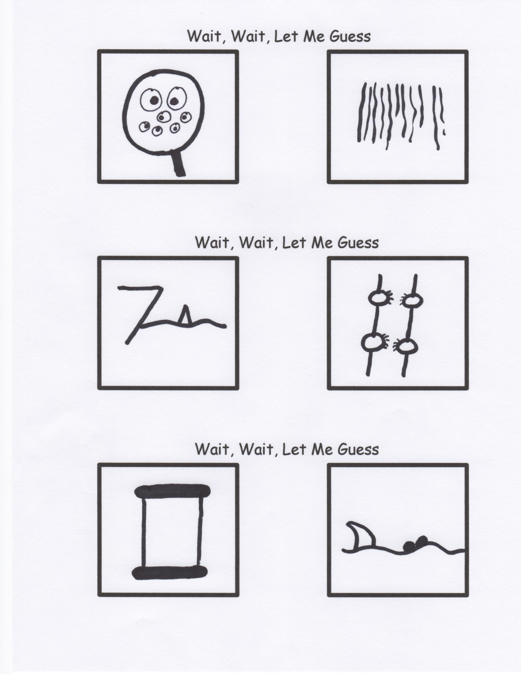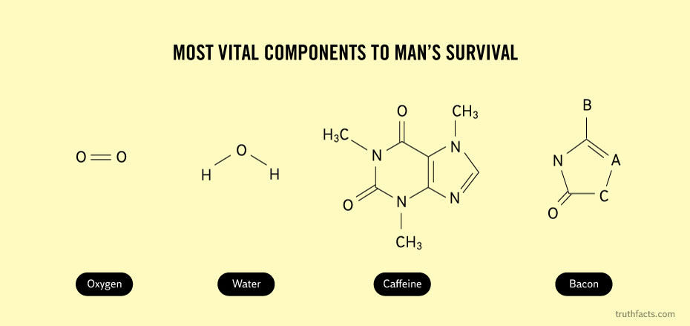

***We continue today with our question and answer time. If you have not had an opportunity to submit a question, Ms. Jeanette has paper and pencils for you to do so.***

Before

After

Remember, friendship is the greatest treasure of all…unless you have a magic pony!