**July 21, 2013**

**Volume 1, Issue 41**

Sunday School Times

***Stuff For Today***

• Eat your vegetables

• Cat food

* Beach In A Bottle—only $19.95!

Published almost weekly, but more like…..whenever, so get used to it, OK?

# Sunday School Shopping Network

**By Mr. Lyle (mrlyle1@gmail.com**

***Matthew 6:33***

***But seek ye first the kingdom of God, and His righteousness, and all these things will be added unto you***

In 1776, Thomas Jefferson penned one of the most memorable phrases into the US Declaration of Independence. “Life, Liberty, and the Pursuit of happiness.” The founding fathers warned that the success of our Republic was directly tied to our ability to maintain a coherent interpretation of our laws—laid side by side with the Bible for reference!

Our culture left that concept behind years ago, and is suffering the results. The pursuit of happiness has become an “”all about me”” attitude. One has to only watch TV for a few minutes to realize what motivates many.

Our pursuit of beauty, our pursuit of food, our pursuit of sports, our pursuit of material possessions, are not a true pursuit of happiness. Those who attain those goals without the balance of Scripture are empty in the end.

As Christians, we are to have priorities. That is often difficult, as the world around us screams of its plans for us. And those strategies and tactics are generally diametrically opposed to the Bible. God must have first place in our lives. Nothing else, no one else will do.

Consider a large jar. How would you successfully place a large rock, handfuls of small stones, a bucket of sand, and several bottles of water, into the container?

Trial and error will reveal a solution, but so will some common sense and thought.

Step one must be the large rock. It simply will not fit with anything else in the way. God, likewise, should be given first consideration. Our culture today does not see this concept at all.

Step two involves the small stones. Once the big rock is given its choice position, there are still many areas to be filled by the various sized stones. In the beginning God created—a family. The family structure and stability is vitally important! Without it, a country fails and falls. Our attention to family must be given prominence. It is that important.

Thirdly, we pour in the sand. It is truly amazing how much sand will fit into all of the cracks and corners still remaining in the jar. If God is first and family second, then others come third. To touch the lives of those around us is why we are here.

And finally, we add the water. A jar full of rock, stones and sand will still hold an astonishing amount of water. And here lies one of the greatest lessons we can learn about God’s priorities. When God has first place, and all of the other things He has called us to participate in are in their appropriate position, there is still plenty of time for ourselves.

God has a plan for us, and that plan involves our enjoyment of all that He has created and given to us. Lets keep our priorities straight, and pursue true happiness!

**Research Reveals World’s Most Popular Vegetable**

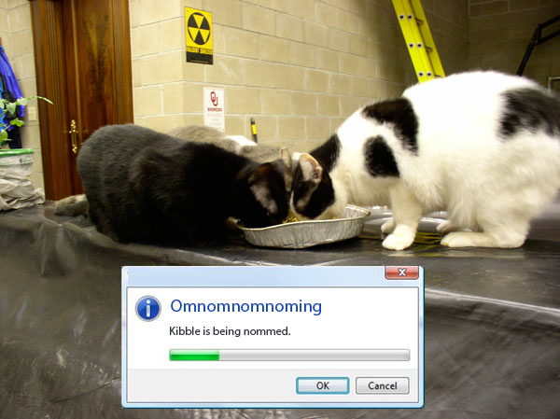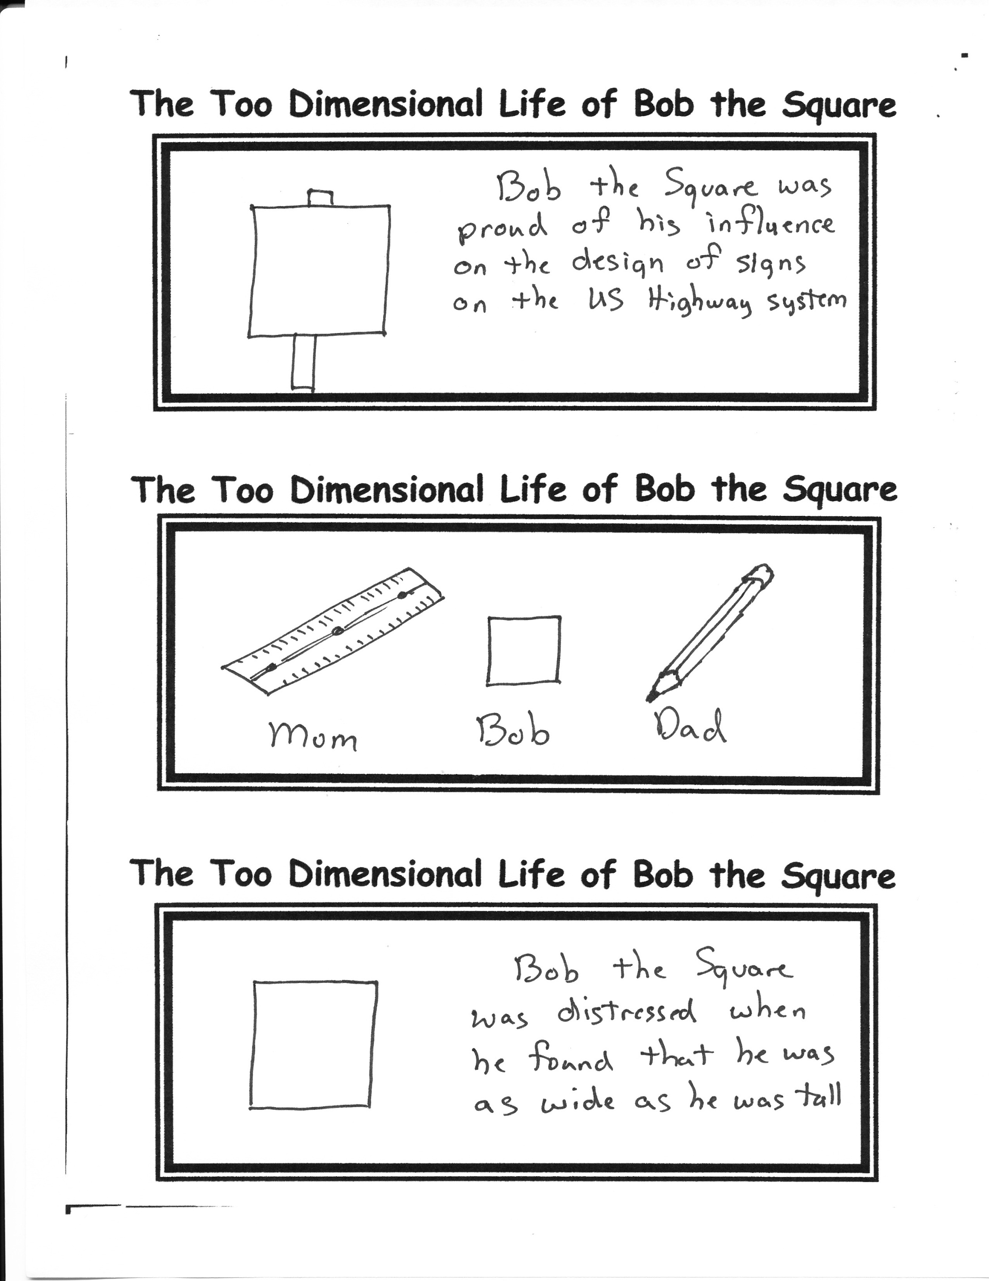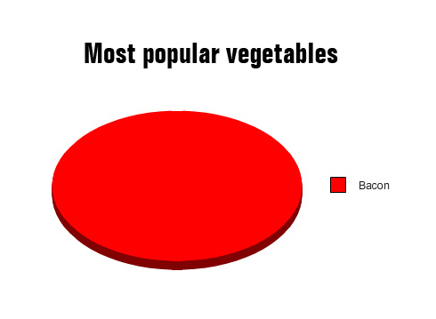

**Always remember this little fact:**

Cats are made up entirely of cat food and water!

**Things to Remember (According to our cats)**

**1. Kitty Nibbles**

**2. Cat food**

**3. Kitty Food**

**4, Cat nibbles**

**5. Kitty cat nibbles**

**6. Kitty cat food**

**7. The Alamo**

By Mr. Lyle (mrlyle1@gmail.com)