**July 14, 2013**

**Volume 1, Issue 40**

Sunday School Times

***Stuff For Today***

• Pictures from this week

• Aerial view of Sudoku KS--explained

Giraffitti--explained

Gargling at a fountain--explained

Laws of acceleration--explained

* The end—really?

Published almost weekly, but more like…..whenever, so get used to it, OK?

# The End

**By Mr. Lyle (mrlyle1@gmail.com**

***Daniel 3:14-15***

**13 Furious with rage, Nebuchadnezzar summoned Shadrach, Meshach and Abednego. So these men were brought before the king, 14 and Nebuchadnezzar said to them, “Is it true, Shadrach, Meshach and Abednego, that you do not serve my gods or worship the image of gold I have set up?**

Our study begins with the greatest world empire ever seen upon the face of the earth. Nebuchadnezzar, the greatest governmental leader the world has ever seen, was beset with some astonishing flaws. One of those shortcomings arises to the forefront in Chapter 3 of the book of Daniel.

We find there the story of a man who builds a magnificent golden statue to himself, and then attempts to force everyone to worship it. Enter—three Hebrew young men who refuse to bow in honor and worship. This act of disrespect and disobedience infuriates the king. In anger, he commands that they be burned alive.

We see courage, commitment, and faith played out in real life as they are thrown into the fire, but miraculously saved from harm by God. This kind of story often finds its way into grade school level church curriculum. We read it, or hear it told there, but often, because we relegate it to “little kid’s status”, we miss some very important concepts found there.

Often, Old Testament stories are parallels or “types”, (as Bible scholars would term them), to New Testament ideas. This story has a unique attribute that places some very interesting questions on the table. Where is Daniel as all of this is going on?!

The king had given explicit instructions that all of the leadership in the country were to be present at this ceremony. Daniel is a VERY high-ranking official and is nowhere to be found! Where was he? His three friends were “raked over the coals”—literally. But he wasn’t. WHY?

I believe this historical incident is a type or picture of a coming event. The judgment of God that will one day fall upon this world will be terrible. Many will die in intense pain and suffering. But God’s people, the Christians, His children, will be spared from His wrath. Daniel represents that group.

The Bible says that those of us who believe and are alive in that day, will be caught up to be with Him before His heavy hand of judgment falls upon the earth. But His chosen nation, Israel, will be brought through the extreme trials as a testament to God’s love for them. The three that went into the fire parallel that group.

God is love, to be sure. God is also judge, jury, and executioner, and rightly so. He is perfect and will not abide with anything less.

**Pictures With Captions**

By Mr. Lyle (mrlyle1@gmail.com)

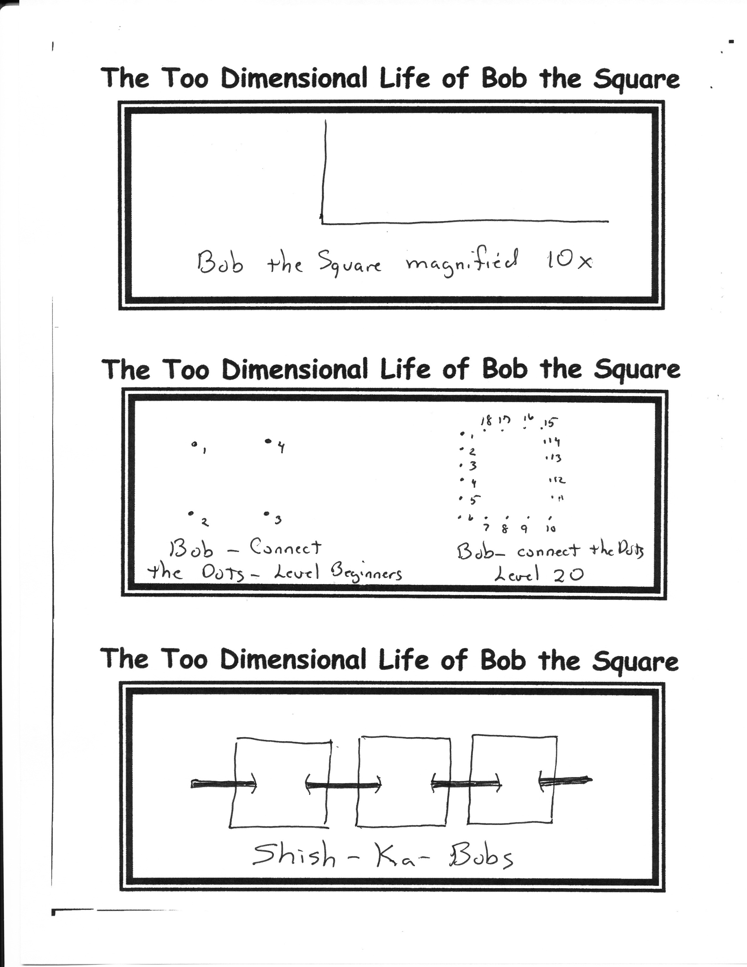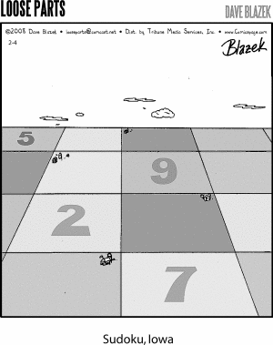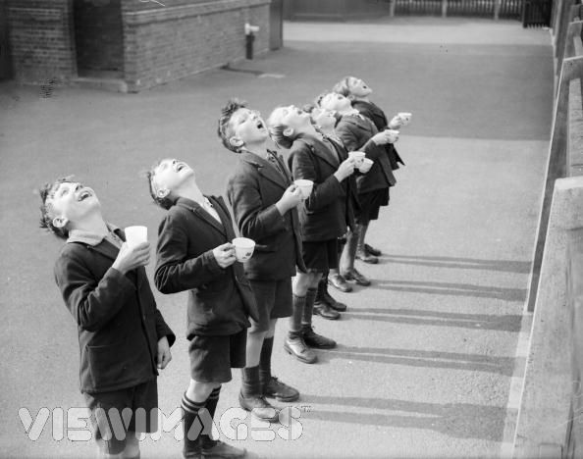

And just how fast do YOU drive?

**This fella may be cute now, but by the time he turns 14, he will have joined an inner city gang. Doing drugs, mugging innocent old ladies, and drive by shootings will be his specialty. And he will learn to tag buildings with spray painted Giraffitti (That’s vandalism sprayed very, very high!)**

An aerial view of Sudoku Kansas

Some drink from the fountain of knowledge—others just gargle