**April 7, 2013**

**Volume 1, Issue 28**

Sunday School Times

***Stuff For Today***

• Some cookie history

• Next Week Q and A

• Welcome to Snickerdoodleville!

Published almost weekly, but more like…..whenever, so get used to it, OK?

# Snickerdoodleville—A Great Place!

**By Mr. Lyle (mrlyle1@gmail.com**

***Ephesians 6:17***

***17Take the helmet of salvation and the sword of the Spirit, which is the word of God.***

Heaven is, and will be, an amazing place. We do not have the ability as human beings to even begin to comprehend what is in store for those of us who are Christians.

The Bible describes small bits and pieces to us, but even Paul says, at best, we can only look through a shadowy, dark glass towards heaven. Think the most amazing thought that you can think about what Heaven might be like, and rest assured, you are probably not even close to the truth about this most amazing place!

God created the universe in six days. Contrast that with the final words of Jesus when He told his disciple that He was going to prepare a place for them (and us). That was over two thousand years ago.

And Heaven will be forever! We struggle with infinity. This is my favorite description of one day of eternity.

*Imagine a solid granite mountain 100 mile wide, 100 miles long, and 10 miles high. Only once every 1000 years, a little chickadee comes and sharpens its little beak on the top of that huge mountain. During that brief sharpening process, an infinitesimal speck of the mountain is scuffed aside When that entire mountain has been worn away, not even one day of eternity will have passed!*

God has a hard and fast rule—no one is allowed into Heaven unless they meet the dress code. The key piece of attire is the helmet of salvation. Absolutely no one passes without it.

We use many phrases to describe salvation, e.g. *becoming a Christian, being saved, inviting Jesus into our heart, being born again.* Essentially they all refer to the idea that we need God in our lives. We must recognize that we are sinful creatures, incapable of perfection, and believe that Jesus paid the price for our shortcoming. And ask God to do for us what He has promised, And He will.

.

**A Little Cookie History**

By Mr. Lyle (mrlyle1@gmail.com)

As a result of extensive research, and an exceptionally dynamic imagination, I would like to forward my own hypothesis of the origin of the name *snickerdoodle.*

In 1573, a Dutch nobleman named Baron Von Hayd D’ood was visiting the King Iam Overstoffed. During his visit there, he was served a delightful sugar cookie, made by the Royal Bakery Chef just for the occasion. History records that at some point during their meeting, the king leaned over and said *Hayd D’ood, what do you think of the sugar cookies?* He was taken aback by the question and stumbled a bit in his reply as he compared them to a special cookie from his home town. *They are like, Wowman, like totally…*but he never finished the sentence as he choked on a cookie.

So as to the origin of the name *snickerdoodle?* I have absolutely no idea!

But the next time you hear someone using phrases like *Hayd D’ood, that’s like, Wowman, like D’ood!,* you will have a historical frame of reference and context in which you can place the comment.

D’ood!

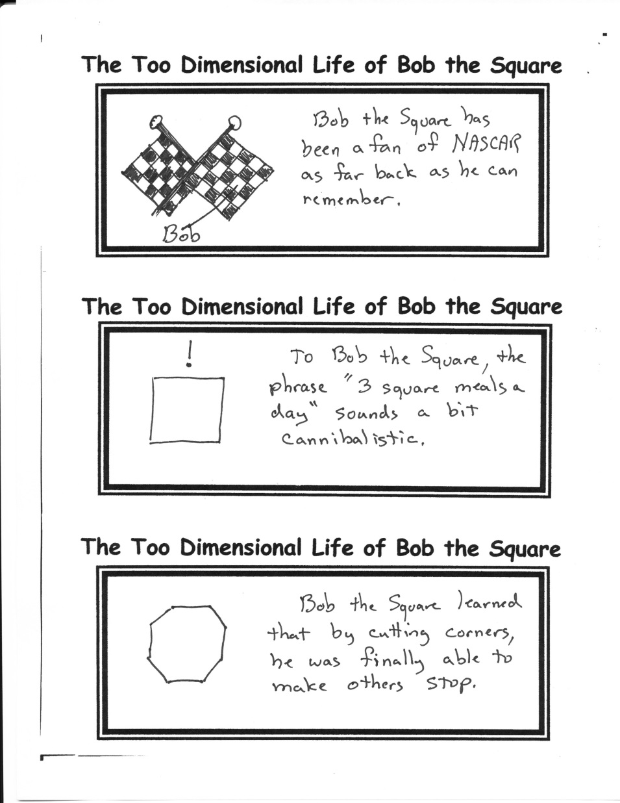

**Sometimes I Amaze Even Myself!**

***Observation:*** The Wicked Witch melts with the application of water.

***Supposition:*** She has never had a bath.

***Deduction:*** No wonder her only friends were flying monkeys!

**Next Week**

Have you ever had a question about the Bible, church, religion, or God that you would really like an answer for but were afraid to ask? Next week is your chance to get your answer. If you choose, you will be able to write your question on a piece of paper—unsigned—and we will look at each question and attempt to find a good answer from the Bible. This is always a very interesting time! No question is off the table! Make it a good one!

**Little Known Fact of Science**

Gravity is stronger on a very cold morning.