**January 27, 2013**

**Volume 1, Issue 19**

Sunday School Times

***Stuff For Today***

• How much wood would a Superman chuck, if a Superman could chuck wood?

• How Sue Roberts signs all of her letters.

• What can you make with $2,000,000 worth of solid gold?

Published almost weekly, but more like…..whenever, so get used to it, OK?

# A Golden Lampstand—Beautiful!

**By Mr. Lyle (mrlyle1@gmail.com**

***Exodus 25:31-39***

*31“Make a lampstand of pure gold. Hammer out its base and shaft, and make its flowerlike cups, buds and blossoms of one piece with them. 32Six branches are to extend from the sides of the lampstand—three on one side and three on the other. 33Three cups shaped like almond flowers with buds and blossoms are to be on one branch, three on the next branch, and the same for all six branches extending from the lampstand. 34And on the lampstand there are to be four cups shaped like almond flowers with buds and blossoms. 35One bud shall be under the first pair of branches extending from the lampstand, a second bud under the second pair, and a third bud under the third pair—six branches in all. 36The buds and branches shall all be of one piece with the lampstand, hammered out of pure gold.*

*37“Then make its seven lamps and set them up on it so that they light the space in front of it. 38Its wick trimmers and trays are to be of pure gold. 39A talent[*[*f*](http://www.biblegateway.com/passage/?search=exodus%2025&version=NIV#fen-NIV-2235f)*] of pure gold is to be used for the lampstand and all these accessories.*

Few pictures in the Old Testament are as rich and complete as this one. The Tabernacle in its entirety speaks about Jesus Christ and His character and attributes. One beautiful piece of furniture, a lamp, teaches us much about God, His Son, and His Holy Spirit.

1. It was made of pure gold—emphasizing His deity.

2. Its base touched the dirt floor—reminding us that Jesus came to this earth and walked upon the same ground we do.

3. It was not cast in a mold, but beaten with hammers into shape—reminding us of what Jesus went through on His way to the cross.

4. As no windows were present in the Tabernacle, it was the only light in the tent—Jesus is indeed the light of the world.

5. It was intricate in beauty. A craftsman was given special artistic talent to make it. It would have been a focal point for anyone in the room—Jesus is to be the focus of our lives as well.

5. The candlestick consisted of seven bowls of oil, each with a wick, that when lit, showered light into the otherwise darkness of the room. The clear, odorless oil is significant as well. We will discuss its role in this model that God gave us.

**Gripping!**

**A Question**

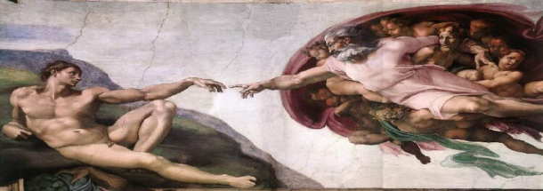

By Mr. Lyle (mrlyle1@gmail.com)

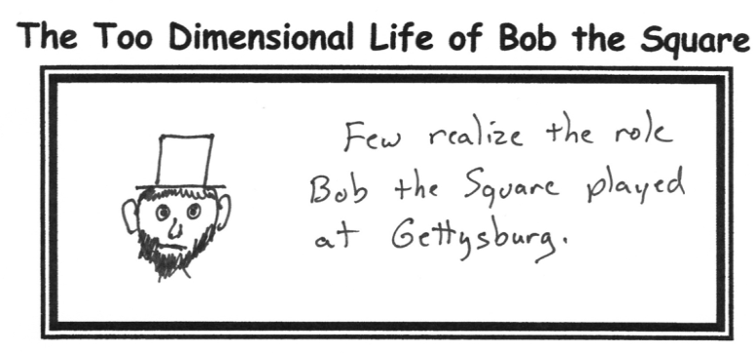

**Upcoming Dinner Theater**

The March meal will be absolutely incredibly fun!!!!! Do not miss it. Critics have hailed as:

*More fun than when the Penguins of Madagascar did that funny thing they did in the movie when the guy said that stuff and then the other guy laughed and then the penguins did that thing, and I laughed and laughed and it was sooooo great!*

As great as that was—this will be even better!

This well-known scene from the Sistine Chapel shows God reaching to touch the tip of the finger of man. For those who claim Christ as their Savior, the connection is more than just a touch. John 10:28-29 stipulates that we are in His grip. Imagine the strong arm of the Lord holding onto your own arm—and not letting go. Our salvation is not secured by our strength, but rather, it is bound by His hold on us

If Superman is as powerful as the comics and movies say he is, and if he is as willing to fight for Truth, Justice, and the American Way, like the old TV program used to say, then how would we use his abilities to work the most good for everyone?

In one of his movies, he accelerated himself to beyond the speed of light and turned back time to save Lois Lane. The amount of energy needed to accomplish that task is astronomical!

It would seem then, in the best interest of humanity, for him to be asked to use his amazing power to turn a gigantic electrical generator 24 hours a day—generating billions of free kilowatt hours of power for the world to use.

Just a thought.