**January 6, 2013**

**Volume 1, Issue 16**

Sunday School Times

Published almost weekly, but more like…..whenever, so get used to it, OK?

***Stuff For Today***

• Todays Bible lesson

• The greatest card trick in the world (well maybe) performed here live!

• The theological ramifications of the imputation of the righteousness of Christ upon the heart of the regenerated believer.

# The Greatest Miracle

**By Mr. Lyle (mrlyle1@gmail.com**

*;****Romans 4:20-25***

***20****He staggered not at the promise of God through unbelief; but was strong in faith, giving glory to God;*

***21****And being fully persuaded that, what he had promised, he was able also to perform.*

***22****And therefore it was imputed to him for righteousness.*

***23****Now it was not written for his sake alone, that it was imputed to him;*

***24****But for us also, to whom it shall be imputed, if we believe on him that raised up Jesus our Lord from the dead;*

***25****Who was delivered for our offences, and was raised again for our justification.*

Few Christians today can define the word *imputation.* It is a word rarely used in our everyday vocabulary, and even in church, substitute words are used to help people understand the truth of Romans 4.

The imputation of righteousness to a believer is a most amazing and awesome miracle! It is a miracle that God does for Himself (as well as us), Only He can see it; we wouldn’t even know about it if He hadn’t told us that He has done it.

Although very closely related to concepts like Atonement and Justification, it is important to take the time to analyze this work of God carefully. We will attempt to explain the similarities and differences, subtleties and uniqueness of this miracle.

The imputation of righteousness is an absolute must for anyone making plans to see Heaven someday. God is absolutely perfect, and cannot abide with anything imperfect. We sin. That places us in the latter category. How can God bring anything not perfect into an absolutely perfect place?

Class today will include a visual demonstration to help us understand the truth about this wonderful thing that God does for us.

Who knows, someday, someone might come up to you and ask:

*What are the theological ramifications of the imputation of the righteousness of Christ upon the heart of the regenerated believe?*

*.*You just might have an answer.

**A Few Words of Wisdom For the Year Ahead**

(From Mr. Lyle)

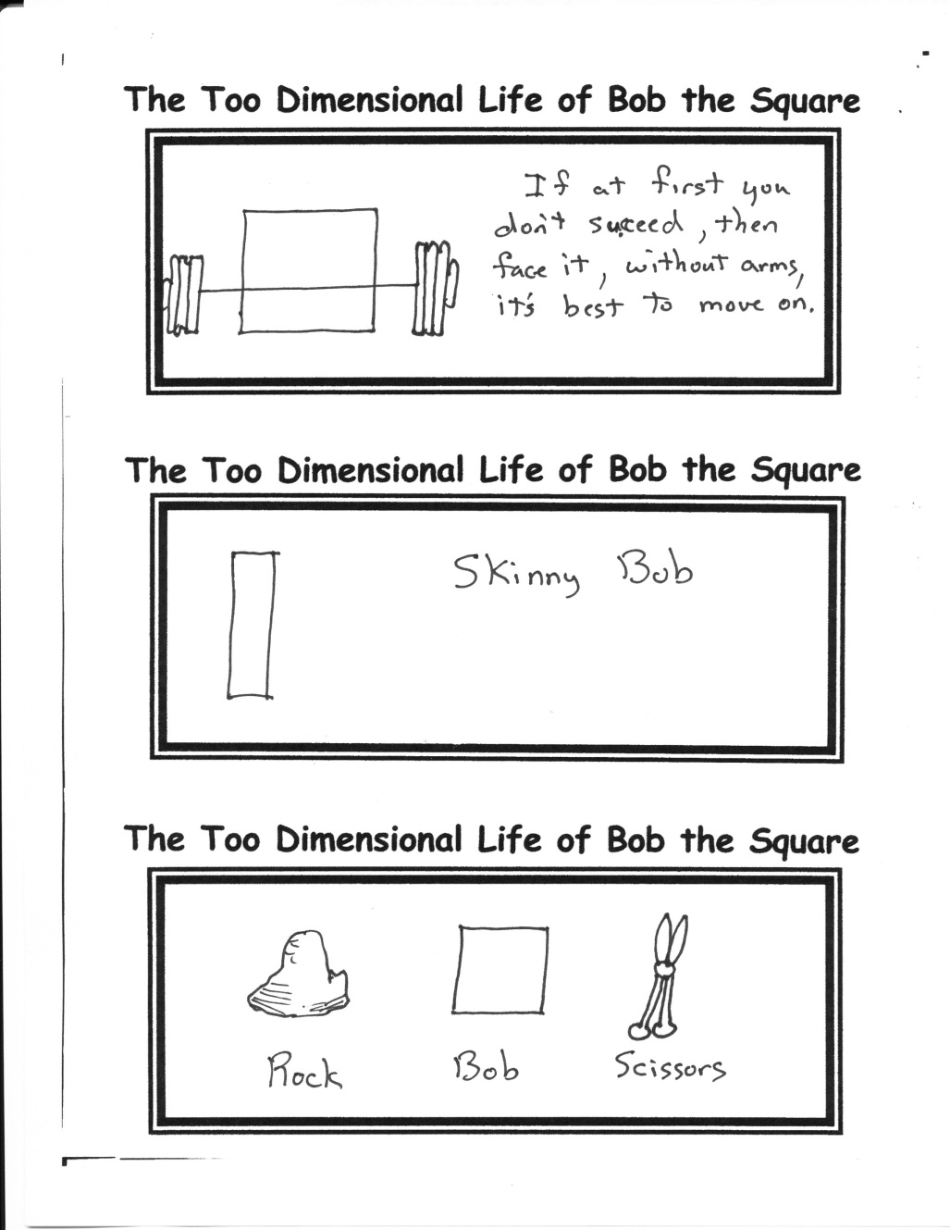

1. Enjoy deadlines, especially the “wooshing” sound they make as they go by.

2. It is so simple to be wise. Just think of something stupid to say, and then don’t say it.

3. Yesterday’s yesterday’s tomorrow’s tomorrow is actually tomorrow’s yesterday—AND THAT’S TODAY!

4. Brush your teeth with someone else today. 4 out of 5 dentists agree—you can’t stop tooth decay by brushing alone.

5. Never buy tickets to an Amish World Series night game.

6. He who becomes a dad

Goes slightly mad.

But, with medication or time,

He can be fine.

The weirdness becomes benign.

By Mr. Lyle (mrlyle1@gmail.com)

**Rscheearch**

Aoccdrnig to rscheearch at Cmabrigde Uinervtisy, it deosn’t mttaer in waht oredr the ltteers in a wrod are , the olny iprmoetnt tihng is taht the frist and lsat ltteer be at the rghit pclae. The rset can be a taotl mses and you can siltl raed it wouthit a porbelm. Tihs is bcuseae the huamn mnid deos not raed ervey lteter by istlef, but the wrod as a wlohe. Amzanig huh??

**Upcoming Dinner Theater**

Do not forget the meal that is planned for March. Critics have hailed it…

… *more fun than a barrel of monkeys peeling potatoes in a Chevrolet dealership while Brandon sings “I Got My Mojo Working and I Thought You’d Like To Know”.*

So plan to be there!